Safe and Respectful Behaviours

When there are concerns about your child’s sexual behaviours, it is important that the family creates a safe home environment.
Personal Space
We all have personal likes and things that make us uncomfortable. ‘Personal space’ is the private area of control inside an imaginary line or boundary that defines each person as separate. Ideally, that boundary helps us stay in charge of our own personal space. It helps keep out the things that make us uncomfortable - unsafe and unwanted feelings, words, images, and physical contact. Solid social rules strengthen the boundary. Behaviours that routinely disrespect or ignore boundaries make children feel unsafe.
In some families, it may be normal to walk around without any clothes on or walk into each other’s bedroom. There’s nothing wrong with this. However, when there are worries about your child showing sexual behaviours, we really need to have a think about making rules about safe behaviours very clear to avoid any confusion. To do this, it often means tightening up the basic family rules. Your child’s behaviour will only change if you have clear rules about behaviours in the home and if these rules are followed.

BE A ROLE MODEL FOR YOUR CHILD’S BEHAVIOURS

If adults in the family show respect for other people’s privacy and personal space, this shows your child what is expected of them in your family.
Set clear family boundaries
- Set clear family guidelines for personal privacy and behaviour. Discuss them with all members of your family and model respecting these guidelines.
- Discuss these guidelines with any other adults who spend time around or supervise the children (e.g., if a child does not want to hug or kiss someone hello or goodbye, then he or she can shake hands instead).
- Let children know that if they are not comfortable being around a particular adult or older child, then you or another adult will let that person know this (e.g., tell him or her that you don’t want your child to sit on his/her lap).
- As a child matures, boundaries may need to change (e.g., knock on the door before entering the room of an adolescent).

There are some adult behaviours which may not be harmful, but can give children a confused message about personal space and boundaries. These behaviours can put children at risk both in the home and outside.

When an adult touches a child in a way that is uncomfortable and doesn’t stop even when the child asks them to or seems uncomfortable, then the message to the child may be that adults can touch her or him any way they want. This creates an unsafe environment.

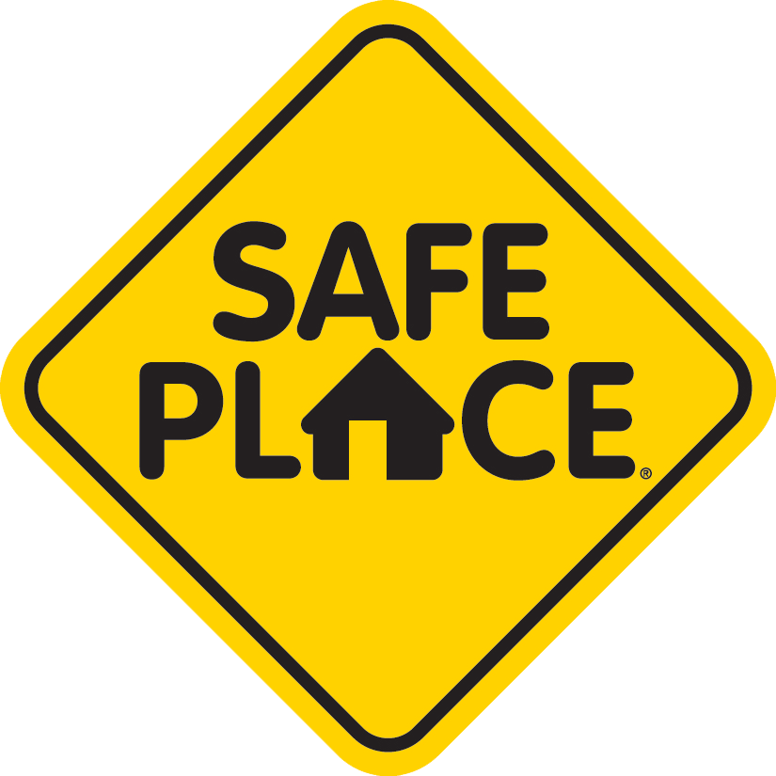

UNSAFE ADULT BEHAVIOURS WHICH MAY CONFUSE A CHILD ABOUT BEING SAFE:
Personal space:
Children need their own private space. Respect this by knocking on their door before entering
- If an adult makes others uncomfortable by ignoring social, emotional or physical boundaries or limits?
- An adult refuses to let a child set any of his or her own limits. Uses teasing or belittling language to keep a child from setting a limit.
- Insisting on hugging, touching, kissing, tickling, wrestling with or holding a child even when the child does not want this physical contact or attention.
It’s safer for you and your child is you respect their personal space
- Frequently walking in on children/teens in the bathroom.

Relationships with children:
- An adult turning to a child for emotional or physical comfort by sharing personal or private information or activities, normally shared with adults.
- Adults having secret interactions with children (e.g. games, sharing drugs, alcohol, or sexual material) or spending excessive time emailing, text messaging or phoning children.
- Insisting on or spending lots of uninterrupted time alone with a child.
Good boundaries help keep children safe. Be clear about your boundaries. Your child needs a parent to be a safe and responsible adult rather than a friend
- If an adult seems ‘too good to be true’ – frequently baby sits different children for free; takes children on special outings alone; buys children gifts or gives them money for no apparent reason.
- Allowing children to consistently get away with inappropriate behaviours.

Sexual conversation or behaviour:
- An adult frequently pointing out sexual images or telling dirty or suggestive jokes with children present.
- Exposing a child to adult sexual interactions or images without apparent concern.
- Overly interested in the sexuality of a particular child (e.g., talks repeatedly about the child's developing body or interferes with normal teen dating).

