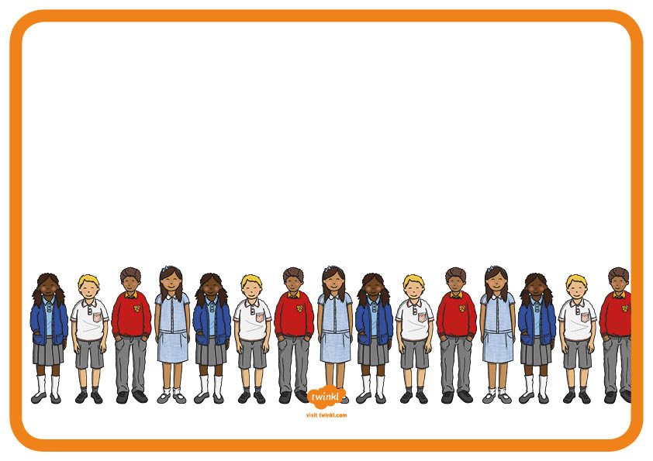
Our Pupil Parliament members are representatives chosen by pupils to help with the decisions
affecting the school, making sure it is the best place to be.

