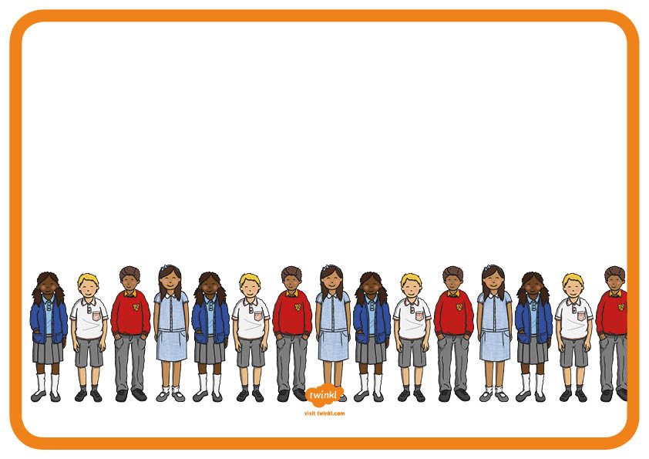
Our Pupil Parliament Mission Statement
We want to implement change to make our school even better.
We hope to create a safe and healthy learning environment.
We hope to give every pupil in our school a voice.
We will give full attention and support towards any pupils who have concerns of any kind. We constantly set new targets for ourselves and work hard to achieve them.
We ensure also that all children in school have their voice heard by holding regular class council meetings.
At our meetings, Pupil Parliament will bring up important issues.

