Welcome to Early Years Foundation Stage

Hello! My name is Mrs Cocks. I will be your class teacher.
I have a little boy called Oliver, and a little girl called Maisie. We love to play outside and go on adventures together!
My favourite book is ‘We’re going on a bear hunt.’ Do you have a favourite book? I love reading stories with my children and with the children in FS1.
When you start FS1 your first topic will be ‘Animal Safari’. This topic is new to FS1 this year and we are looking forward to learning all about different animals. Do you have a favourite animal? My favourite animal is an elephant! I have attached a photo frame to this letter and I was wondering if you could draw your favourite animal and bring it to school with you on your first day? That would be amazing!
We look forward to welcoming you all very soon.
From Mrs Cocks

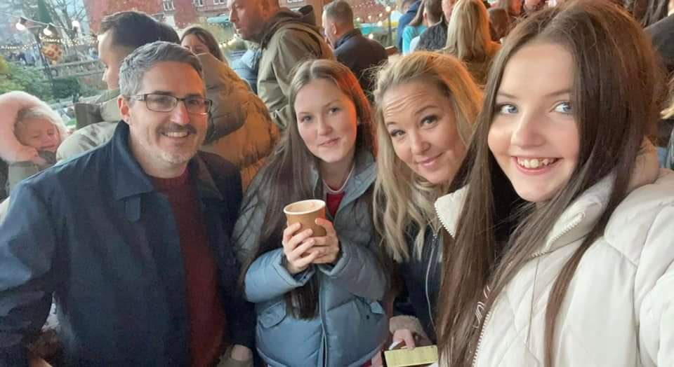
My name is Mrs Moore and I am a Teaching Assistant and will often be in class with you. I have two grown up girls, Maisie and Gracie. We love a good selfie and spending time as a family.
We enjoy trips to the seaside and theme parks. Christmas is our favourite time of the year; we enjoy decorating the tree together and shopping in the Christmas markets.
My favourite book is The Colour Monster by Anna Llenas, it really helps me to understand how I am feeling. I cannot wait to meet you all and share my favourite stories with you.

My name is Mrs Hadfield and I am a Teaching Assistant in your class.
I love to watch football with my family and spend time in my summer house when the weather is nice.
I love reading Room on the Broom by Julia Donaldson and I can’t wait to meet you all and to share this story with you.

My name is Mrs Clare and I am a Teaching Assistant and will often be in your class. I like to read, go for nice walks and I love to spend time with my family, friends and my sausage dog - Crusoe.
My favourite book is also Room on the Broom! I can’t wait to get to know all of you. We will have so much fun together.

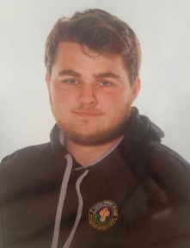
Hello, my name is Mr Lyons and I am a Teaching Assistant in your class. I also teach PE in school and I run the after-school Sports Clubs.

I like to watch football in my spare time and my favourite team is Sheffield Wednesday. My favourite book is Roald Dahl’s - James and the Giant Peach. I can’t wait to find out what your favourite book is. See you all soon.

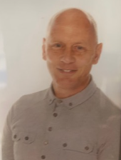
Hello, my name is Mr Whiting and I help out in your class every afternoon. I always read a story to the children at home time and my favourite one to read is Billy the Bully. It’s a fun story with a really positive message and I look forward to sharing this book with you all.

I love to watch football and my favourite team is Sheffield Wednesday. I often go and watch them play.
See you all soon!

Starting school- A poem for children

School starts soon and I just want to say,
I’m sure you’re feeling nervous about your first day,
But please don’t worry we’ll have lots of fun,
You can play and make friends with everyone.
You may feel uncertain or a little unsure
But you’ll learn to love school more and more.
I’m so excited to see you and teach you new things,
Together, we’ll enjoy what each new day brings.
The school day will whizz by and before you know,
Your family will be here and back home you go!

My Favourite Animal

