**Easter Events 2025**

The children have had lots of fun today taking part in our Easter Activities. This morning the children visited St Thomas Church for an Easter Service.

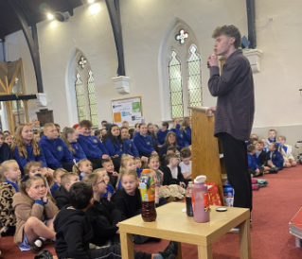

The children have enjoyed an egg and spoon race, egg shackling and egg rolling competitions and our EYFS children took part in an Easter Egg hunt and also had a visit from the Easter Bunny who gave them all a sweet treat. The children have also made some Easter Cards for their families.

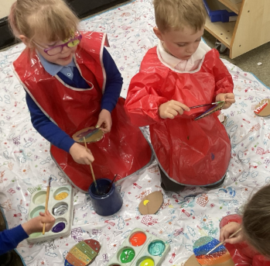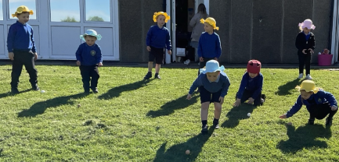

Thank you to all the children who took part in our Egg Decorating competition, your designs were amazing (see overleaf for photos), well done to you all. Mrs Sherwood presented the winners with their prizes this afternoon.

The raffle was drawn this afternoon and Mrs Sherwood gave out the prizes to each of our winners. Congratulations to you all. Thank you to everyone who purchased raffle tickets, we raised £82 in total which will go towards the paint for our Library refurbishment.

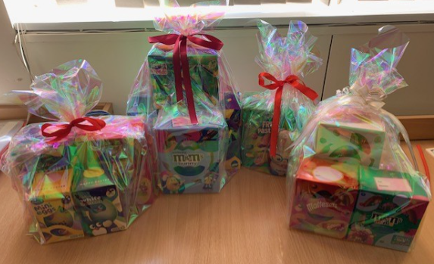

**Egg Decorating Competetion Entries**

