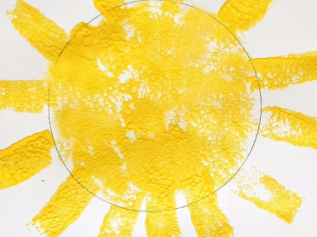****Kilnhurst St Thomas’ CE Primary Academy

**Early Years Open Evening**

|  |
| --- |
| We are inviting parents, carers and children to take a tour and meet our friendly teachers in our flourishing nursery and reception classes.  **Everyone is welcome.**  An ideal opportunity for September starters. |
|  |
| Please contact the school office for further information on 01709 570297 or email [enquiries@stp.dsat.education](mailto:enquiries@stp.dsat.education)  **Our open evenings on the following dates.**   * Wednesday 21st May 2025 3.30pm – 4.30pm * Wednesday 15th October 2025 3.30pm – 4.30pm |