Welcome back to the Autumn Term.
Kilnhurst St Thomas C of E Primary Academy Newsletter
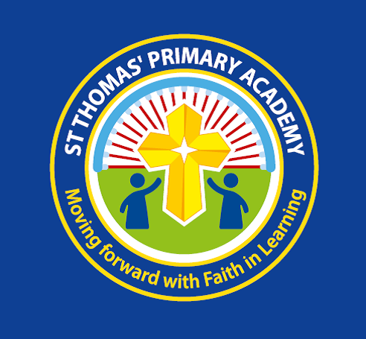
Week ending 8th September 2023
Apologies for the brief newsletter – but due to staff illness we have been unable produce a more in depth newsletter.
Celebration Assembly
This will be next Tuesday 12th September, all parents will be notified by their child’s class teacher, if their child is receiving a Learner of the Week award.
After School Clubs
These will start week commencing 18th September and more details will be sent out next week.
Friends of St Thomas’
Thank you to all who have already responded. Mrs Sherwood will be leading a face-to-face presentation about what this voluntary role involves at 9.15am on Friday in the school bungalow alternatively there will be a Zoom presentation at 6pm on Monday 18/9/23.
School Website
Last year we launched our new school website, please refer to it for key dates, events in school, term times and much more! You can find it clicking on the following link
https://www.stthomas-kilnhurst.co.uk/

Next Weeks Menu
Please see attached next weeks dinner menu.

