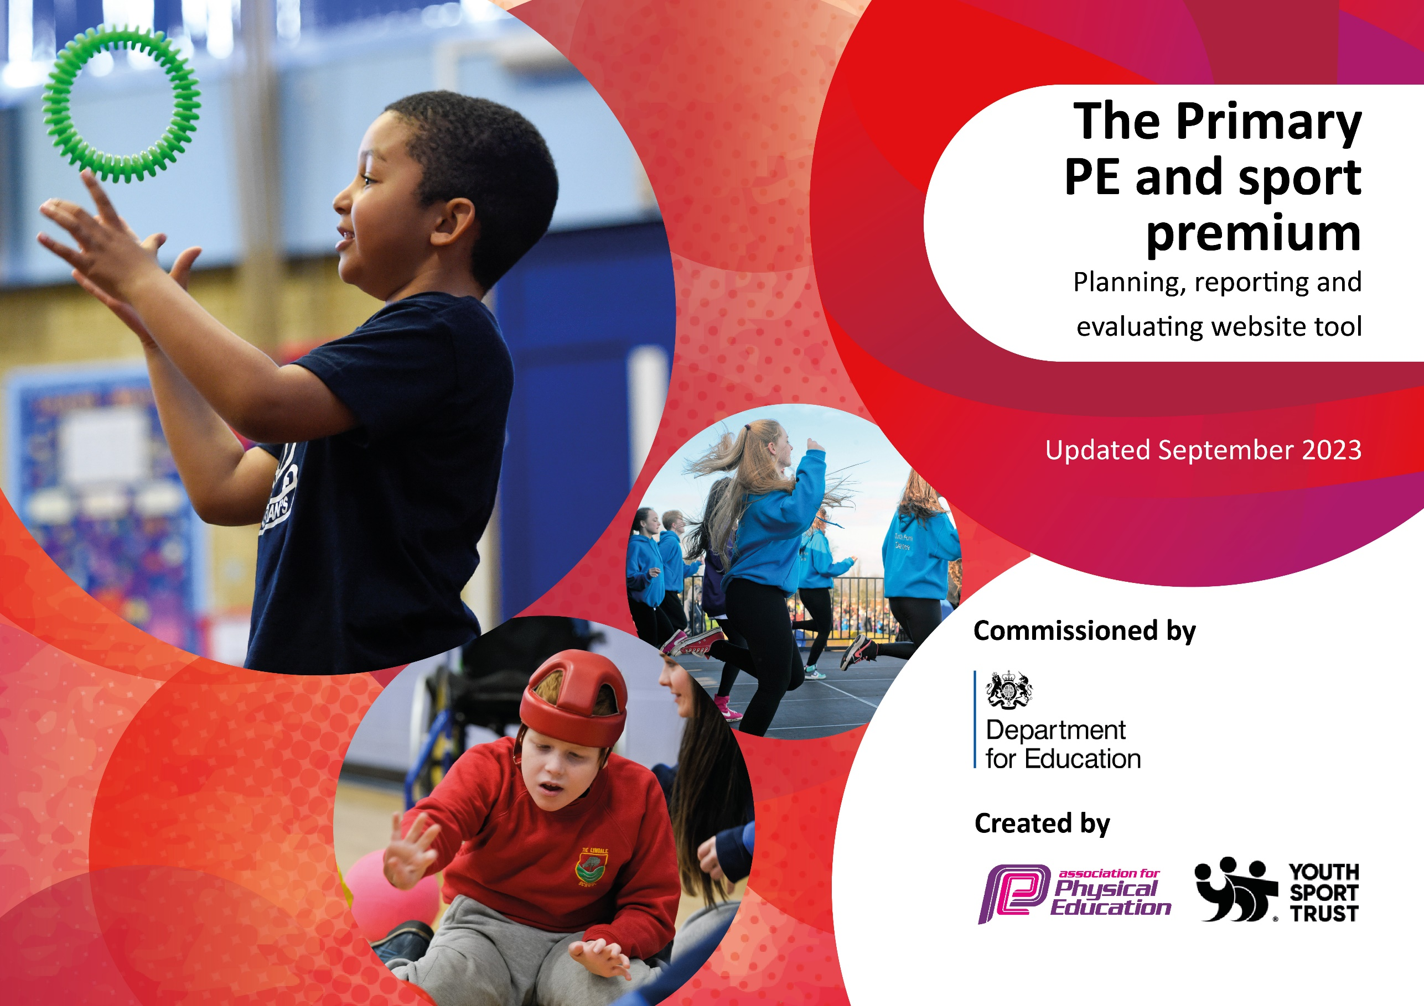

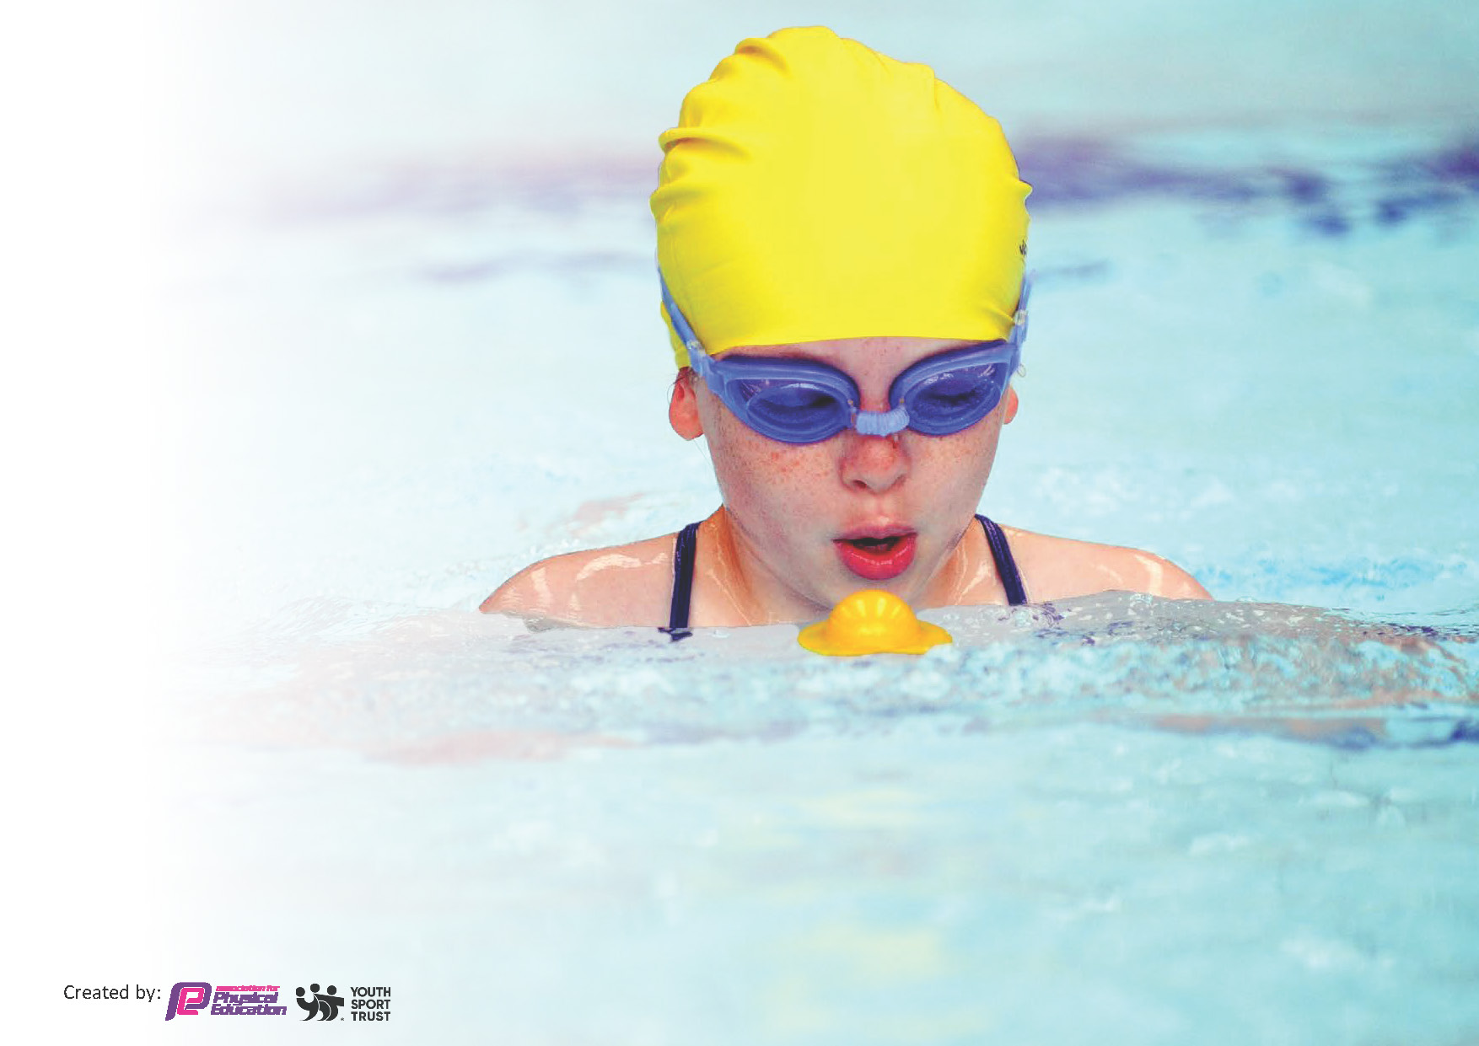
This template can be used for multiple purposes:
by:
- It enables schools to effectively plan their use of the Primary PE and sport premium
- It helps schools to meet the requirements (as set out in guidance) to publish information on their Primary PE and sport premium
- It will be an effective document to support Ofsted inspections enabling schools to evidence progress in Physical Education (PE) and evidence swimming attainment, which forms part of the PE National Curriculum. We would recommend schools consider
the Intent, Implementation and Impact of any spend, as examined within the Education Inspection Framework.

It is important that your grant is used effectively and based on school need.

Schools must use the funding to make additional and sustainable
improvements to the quality of the PE, School Sport and Physical Activity (PESSPA)
they offer. This means that you should use the Primary PE and sport premium to:

- Build capacity and capability within the school to ensure that improvements made now will benefit pupils joining the school in future years
- Develop or add to the PESSPA activities that your school already offers.

The Primary PE and sport premium should not be used to fund capital spend projects; the school’s core budget should fund these. Further detail on capital expenditure can be found in the updated Primary PE and sport premium guidance.

The Primary PE and sport premium guidance, outlines 5 key priorities that funding should be used towards. It is not

necessary that spending has to meet all the key priorities, you should select the priorities that you aim to use any funding towards.

Although completing this template is not a requirement for schools, schools are required to publish details of how they spend this funding. Schools must also outline what the impact this funding has had on pupils’ PE and sport participation and attainment and how any spending will be sustainable in the future. All funding must be spent by 31st July 2024.

The Department for Education has worked closely with the Association for Physical Education (afPE) and the Youth Sport Trust (YST) to develop this template and encourages schools to use it. This template is an effective way of meeting the reporting requirements of the Primary PE and sport premium.
Review of last year’s spend and key achievements (2022/2023)

We recommend you start by reflecting on the impact of current provision and reviewing your previous spend.

Activity/Action | Impact | Comments
- Tribe Time to promote fun, active outdoor learning experiences and Outdoor Adventurous Activities (OAA).  Action: Termly, each Class rotates and works with a different member of staff. Children developed their OAA skills. The Children worked with different staff & acquired new knowledge and skills. Activities included (orienteering, scavenger hunts, gardening, photography, bush craft, archery & team games).  - At lunchtime play, the playground will have a range of equipment to promote physical activity (skipping ropes, stilts, bats, balls, space hoppers & beanbags).  Action: Children have access to range of equipment All stock has been replenished so that staff can deliver a well-balanced PE curriculum. Children have access to a range of equipment that promotes their curiosity, engagement, fundamental skills and physical activity. T  - The School has achieved Gold Active Travel Award, to works towards the platinum award. School continues to work towards the Healthy Schools Accreditation  Action: The school promotes travelling to school and has implemented badge incentives. • Children know the importance of promoting an healthy active lifestyle • Children know the affects carbon emissions has on the plant.  - School PE Subject Leader supports the teaching and learning. Their knowledge is used to improve CPD and to act as a legacy to enhance PE teaching across the school.  Action: PE is delivered by an experienced member of staff to enhance their PE sessions. • Children have a better understanding of each activities’ rules and specific technique • Children can be identified as gifted and talented or a child who needs additional support.  - Implement the peplanning.org scheme of work to enable the staff to make accurate assessments of the children’s ability.  Action: Children are exposed to a structured, broad and balance curriculum • They are aware of the skills (procedural knowledge) and declarative knowledge for each activity • They improve their knowledge of fundamental skills, rules, technique, tactics and terminology.  - The school signed up to Rotherham United Silver Package.  Action: This package offers: Staff CPD/ Whole School Sports Festivals /Additional inclusive competitions/ Cross-curricular workshops / Prize incentives.  - St Thomas will offer afterschool Clubs throughout the academic year.  Action: Boys and girls football (Autumn) Gymnastics and apparatus club (Summer) Netball (Summer) Multiskills (Autumn) Rounders (Summer) Archery (Spring) Hockey (Spring) Rugby (Spring).  - Sponsored local charity events will continue.  Action: PE Lead organized charitable event for MIND and a local charity.  - The children will attend competitions organized by the School Games Lead.  Action: All KS2 children get exposure to competitions, provides opportunities for school to club links and promotes physical activity.  - PE Leaders collaboration across the academy.  Action: PE leads across the Dsat Academy have organized school competitions. | Tribe time: Both children and staff enjoy Tribe Time. It has improved our OAA (Outdoor Adventurous Activity) curriculum. Also, the outdoor learning promotes team work and additional physical activity.  School have replenished their PE equipment (footballs, basketballs, Frisbees & beanbags). Lunchtime supervisors and playground leads get out lunchtime equipment so all year groups can access it. All stock has been replenished so that staff can deliver a well-balanced PE curriculum.  Teachers complete an interactive register. More children travel to school actively and achieve their badges. Whole school active travel week promotes and celebrates traveling to school actively.  PE Subject Leader has attended DSAT PE CPD School PE HTLA who leads lunchtime sports clubs and afterschool clubs. PE coordinator and HTL Attend and take lead on sporting competitions. Experienced staff have supported teaching staff, shared knowledge of how to deliver the school’s PE scheme of work (PEplanning.org). They work with all year groups and are able to support the school’s assessment of pupils. It is essential for the identification of both gifted and pupils and pupils who need support. HLTA has been used in the school’s Nurture provision in the afternoon to support children with SEMH needs, using sporting activities.  Staff are confident at delivering well-structured PE lessons. The assessments of the children’s abilities are clear which will support their summative assessment of each child.  Children gained an in depth understanding of different sports through the festivals • More children got exposure to competitions • Children accessed cross curricular learning delivered by experienced Rotherham United Coaches. Staff gained CPD to enhance their teaching. Each class has attended numerous external whole school sporting festivals delivered by Rotherham United. St Thomas attended a Halftime Superstars Competition on a Saturday were KS2 children played at the New York Stadium during halftime. The additional competitions are inclusive and have enabled more children to experience competitions.  Children gained additional opportunities to improve their activity levels. The school offered a range of sporting experiences aimed at most year groups. The clubs promoted school to club links. It Increased the children’s chances of leading a healthy lifestyle.  All children recognized the importance of raising money for charity. The children, staff and community came together to support a local charity.  The children in KS2 attended School Games, D Sat Local Cluster, Rotherham United and local school competitions. HLTA and PE lead supported these events afterschool. There were invitation only additional training sessions in preparation for the competitions.  Our Academy Cluster St Thomas, Thrybergh Fullerton and Trinity Croft created a sporting calendar. The games were inclusive and provided children opportunities to compete. | Tribe Time will continue next year. As a team we have analyzed ways to enhance and develop it further.  The school needs to continue to do regular stock checks to ensure that there is equipment for everyone. PE equipment needs to be put neatly away in the PE cupboard. PE equipment needs to be replenished when needed.  More children travelling to school actively. More families adopt the park and stride approach to implement being active into their morning routine.  Teachers feel more competent and confident at delivering PE. Children attend and access more sporting competitions.  The school will continue to use the peplanning.org next year.  The school have continued to buy with the Rotherham united silver package.  More clubs will be available this year for KS1 & KS2. This will enable them to be active and provided additional childcare for parents. We will continue to deliver a range of afterschool clubs.  We will continue to use sport/ physical activity to raise money for charities.  We will continue to sign up attend the School Games, Trust inter-school games and Rotherham Utd Competition next year.  Our collaboration will continue next year.

Key priorities and Planning
This planning template will allow schools to accurately plan their spending.

Action – what are you planning to do | Who does this action impact? | Key indicator to meet | Impacts and how sustainability will be achieved? | Cost linked to the action
To continue to gain the School Sports Games Gold Award | -Children attend a broad sporting calendar. (School Games / D Sat Academy Cluster / Rotherham united Community Sport Trust)  -Afterschool club enhance the children’s exposure to leading a healthy lifestyle.  -More intra school competition  -Playground leaders are trained to deliver physical activities.  -Whole school brain breaks opportunities to promote physical activity. | Key indicator 2 -The engagement of all pupils in regular physical activity – the Chief Medical Officer guidelines recommend that all children and young people aged 5 to 18 engage in at least 60 minutes of physical activity per day, of which 30 minutes should be in school.  Key indicator 4: Broader experience of a range of sports and activities offered to all pupils. | More pupils meeting their daily physical activity goal, more pupils encouraged to take part in PE and Sport Activities. | £1000

Support & CPD for teachers | -PE coordinator attend CPD and feeds back to staff.  -Questionnaire is sent to staff and training provided on their weaker areas. | Key Indicator 1: Increased confidence, knowledge, and skills of all staff in teaching PE and sport. | Primary teachers more confident to deliver effective PE supporting pupils to undertake extra activities inside and outside of school. | £1000.
PE specialist to continue to raise PE profile | -Sports lead HLTA is used to enhance PE. Deliver afterschool clubs & lunchtime clubs. Attend sporting events. Support staff. | Key Indicator 3. The profile of PE and sport is raised across the school as a tool for whole school improvement  Key indicator 5: Increased participation in competitive sport. | PE specialist will have a timetable for lesson cover, lunchtime & afterschool clubs and dates on the sporting calendar. | £10, 000
Delivery a broad and balanced curriculum | -Sports equipment is replenished so that the school can deliver a broad, balanced curriculum.  -Class sets of sporting equipment  -External coaches brought in to provide a broad range of experiences. | 2. Engagement of all pupils in regular physical activity  4. Broader experience of a range of sports and activities offered to all pupils | Children will become more confident and competent at using a broad range of equipment. | £6000

Key achievements 2023-2024
This template will be completed at the end of the academic year and will showcase the key achievements schools have made with their Primary PE and sport premium spending.

Activity/Action | Impact | Comments

Swimming Data
Meeting National Curriculum requirements for swimming and water safety.
Priority should always be given to ensuring that pupils can perform safe self-rescue even if they do not fully meet the first two requirements of the National Curriculum programme of study

Question | Stats: | Further context  Relative to local challenges
What percentage of your current Year 6 cohort can swim competently, confidently and proficiently over a distance of at least 25 metres? | 60% | The children were set to access a 12-week swimming block in Year 3. However due to COVID this was disrupted.
What percentage of your current Year 6 cohort can use a range of strokes effectively [for example, front crawl, backstroke, and breaststroke]? | 30% | The children access the 12-week swimming block. However, the families that continued swimming lesson enabled their child to become a more competent swimmer. Children that were unable to attend additional swimming lesson didn’t become efficient in a range of strokes.

What percentage of your current Year 6 cohort are able to perform safe self-rescue in different water-based situations? | 30% | Use this text box to give further context behind the percentage.
If your schools swimming data is below national expectation, you can choose to use the Primary PE and sport premium to provide additional top-up sessions for those pupils that did not meet National Curriculum  requirements after the completion of core lessons. Have you done this? | No | The school Sports Premium has been used on raising the profile of school sport.
Have you provided CPD to improve the knowledge and confidence of staff to be able to teach swimming and water safety? | No | Staff have not attended any CPD.

Signed off by:

Head Teacher: | Victoria Sherwood
Subject Leader | Mr Ryan Turner PE Coordinator
Date: | 28.7.23

