Curriculum 22 – Subject Sequence for DT

Year Group & Unit  Project Title  Key Concepts  NC PoS Reference | Vocabulary | Knowledge (specific facts or truth components. A knowledge statement will often contain substantive, declarative or explicit knowledge.)  Core Knowledge – Component Knowledge  Specific Knowledge – Composite Knowledge | Skills (the use and application of composite knowledge. A skill statement will often contain implicit, procedural and disciplinary knowledge.)
Year 4  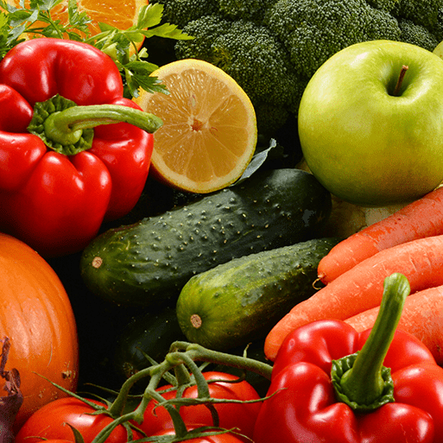  Fresh food, Good food  This project teaches children about food decay and preservation. They discover key inventions in food preservation and packaging, then make examples. The children prepare, package and evaluate a healthy snack.  Key Concepts:  Evaluation  Everyday products  Food prep & cooking  Generation of ideas  Materials for purpose  Nutrition  Origins of food  Significant people  Staying safe  Structures  11 Programmes of study, 11 skills and 14 knowledge statements  Y4 Use research and develop design criteria to inform the design of innovative, functional, appealing products that are fit for purpose, aimed at particular individuals or groups.  Y4 Generate, develop, model and communicate their ideas through discussion, annotated sketches, cross-sectional and exploded diagrams, prototypes, pattern pieces and computer-aided design.  Y4 Select from and use a wider range of materials and components, including construction materials, textiles and ingredients, according to their functional properties and aesthetic qualities.  Y4 Investigate and analyse a range of existing products.  Y4 Evaluate their ideas and products against their own design criteria and consider the views of others to improve their work.  Y4 Understand how key events and individuals in design and technology have helped shape the world.  Y4 Apply their understanding of how to strengthen, stiffen and reinforce more complex structures.  Y4 Understand and apply the principles of a healthy and varied diet.  Y4 Prepare and cook a variety of predominantly savoury dishes using a range of cooking techniques.  Y4 Understand seasonality, and know where and how a variety of ingredients are grown, reared, caught and processed.  Y4 Develop the creative, technical and practical expertise needed to perform everyday tasks confidently and to participate successfully in an increasingly technological world. | Evaluation  evaluation  fulfil design criteria  improve  success  Generation of ideas  build  deconstruct  net  reconstruct  sketch  Everyday products  Tetra Pak  Tupperware  bag  bottle  box  can  carton  cling film  compostable  food packaging  jar  recyclable  recycle  reuse  Materials for purpose  Polystyrene  card  cardboard  cling film  glass  paper  plastic  tin  tin foil  Significant people  Dr Ruben Rausing  Earl Tupper  Gerald Thomas  Henry D Thatcher  Jacob Perkins  Kruger Brewing Company  Louis Pasteur  Nicolas Appert  Peter Durand  Ralph Wiley  TV dinners  Tetra Pak  Tupperware  William Cullen  William Kellogg  best before  canning  drying  freezing  pasteurisation  pickling  refrigeration  salting  saran wrap  use by  Structures  cone  cube  cuboid  hexagonal prism  net  packaging  prototype  triangular prism  Food preparation and cooking  bake  blender  chop  chopping board  cool  crush  cut  garlic press  grate  heat  knife  mash  masher  mix  pastry brush  peel  slice  spread  tear  wash  Nutrition  fresh  healthy  snack | core knowledgeAnnotated sketches and exploded diagrams show specific parts of a design, highlight sections or show functions. They communicate ideas in a visual, detailed way. | Y4 skill 1 Use annotated sketches and exploded diagrams to test and communicate their ideas.
 |  | core knowledgeAnnotated sketches and exploded diagrams show specific parts of a design, highlight sections or show functions. They communicate ideas in a visual, detailed way. | Y4 skill 1 Use annotated sketches and exploded diagrams to test and communicate their ideas.
 |  | core knowledgeDifferent materials and components have a range of properties, making them suitable for different tasks. It is important to select the correct material or component for the specific purpose, depending on the design criteria. Recipe ingredients have different tastes and appearances. They look and taste better and are cheaper when in season. | Y4 skill 1 Choose from a range of materials, showing an understanding of their different characteristics.
 |  | core knowledgeDesign features are the aspects of a product's design that the designer would like to emphasise, such as the use of a particular material or feature that makes the product easier to use or more durable.  specific knowledgeFood packaging provides physical protection for foods and can prevent contamination from microorganisms.  specific knowledgeMaterials, including plastic, paper, cardboard, foil and metal, can be used to package food. Some types of packaging, such as tin cans, can significantly extend the shelf life of some foods. Some packaging is more environmentally friendly than others. | Y4 skill 3 Investigate and identify the design features of a familiar product.
 |  | core knowledgeEvaluation can be done by considering whether the product does what it was designed to do, whether it has an attractive appearance, what changes were made during the making process and why the changes were made. Evaluation also includes suggesting improvements and explaining why they should be made. | Y4 skill 1 Identify what has worked well and what aspects of their products could be improved, acting on their own suggestions and those of others when making improvements.
 |  | core knowledgeSignificant designers and inventors can shape the world.  specific knowledgeFood deteriorates due to the growth of microorganisms. Decay can be prevented or delayed by preservation methods, such as drying, salting, pickling, canning, pasteurising, refrigerating or freezing the food.  specific knowledgeFood packaging plays an important role in keeping foods fresh. The ‘use by’ date shows when the food is no longer safe to eat. The ‘best before’ date shows the date after which the food will lose some flavour or texture. | Y4 skill 3 Explain how and why a significant designer or inventor shaped the world.
 |  | core knowledgeA prototype is a mock-up of a design that will look like the finished product but may not be full size or made of the same materials. Shell and frame structures can be strengthened by gluing several layers of card together, using triangular shapes rather than squares, adding diagonal support struts and using 'Jinks' corners (small, thin pieces of card cut into a right-angled triangle and glued over each joint to straighten and strengthen them).  specific knowledgeMost cardboard packaging is produced from a net. Packages can be strengthened by using thicker cardboard or multiple layers. | Y4 skill 1 Prototype shell and frame structures, showing awareness of how to strengthen, stiffen and reinforce them.
 |  | core knowledgeHealthy snacks include fresh or dried fruit and vegetables, nuts and seeds, rice cakes with low-fat cream cheese, homemade popcorn or chopped vegetables with hummus. A healthy packed lunch might include a brown or wholemeal bread sandwich containing eggs, meat, fish or cheese, a piece of fresh fruit, a low-sugar yoghurt, rice cake or popcorn and a drink, such as water or semi-skimmed milk.  specific knowledgeFoods need packaging to keep them fresh, safe to eat and free from damage. Food packaging also provides nutritional information about the food inside, ‘use by’ and ‘best before’ dates, and the materials and recyclability of the packaging. | Y4 skill 2 Design a healthy snack or packed lunch and explain why it is healthy.
 |  | core knowledgeCooking techniques include baking, boiling, frying, grilling and roasting. | Y4 skill 1 Identify and use a range of cooking techniques to prepare a simple meal or snack
 |  | core knowledgeParticular areas of the world have conditions suited to growing certain crops, such as coffee in Peru and citrus fruits in California in the United States of America. | Y4 skill 1 Identify and name foods that are produced in different places in the UK and beyond.
 |  | core knowledgeChemicals are used in the home every day. They include cleaning products, such as bleach and disinfectant, but also paints, glues, oils, pesticides and medicines. Most chemical products carry a hazard symbol showing in what way the chemical could be harmful. Chemicals should only be used under adult supervision. Appropriate safety precautions, such as wearing goggles and gloves, working in a well-ventilated room, wiping up spills and tying back long hair, should be taken. | Y4 skill 1 Work safely with everyday chemical products under supervision, such as disinfectant hand wash and surface cleaning spray.
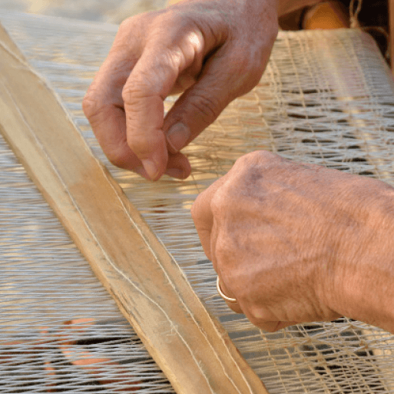  Year 4  Warp and Weft – Art focus  This project teaches children about the artform of weaving and how it has developed over time, including the materials and techniques required to create woven patterns and products.  Key Concepts:  Materials for purpose  1 Programme of study, 1 skills and 2 knowledge statements  Y4 Select from and use a wider range of materials and components, including construction materials, textiles and ingredients, according to their functional properties and aesthetic qualities. | Materials for purpose  appearance  colour  elasticity  material  natural  pattern  shape  synthetic  textile  texture  Yarn  Significant people  loom  weaver  Weaving | core knowledgeDifferent materials and components have a range of properties, making them suitable for different tasks. It is important to select the correct material or component for the specific purpose, depending on the design criteria. Recipe ingredients have different tastes and appearances. They look and taste better and are cheaper when in season.  specific knowledgeVisual elements of yarn include the colour, appearance, shape, texture, elasticity and type. | Y4 skill 1 Choose from a range of materials, showing an understanding of their different characteristics.
Year 4  Misty Mountain, Winding River - Geography focus  (Mini topic for Functional and Fancy Fabrics – art focus)  This project teaches children about the characteristics and features of rivers and mountain ranges around the world, including a detailed exploration of the ecosystems and processes that shape them and the land around them.  Key Concepts:  Everyday products  Materials for purpose  2 Programmes of study, 2 skills and 2 knowledge statements  Y4 Select from and use a wider range of materials and components, including construction materials, textiles and ingredients, according to their functional properties and aesthetic qualities.  Y4 Investigate and analyse a range of existing products. | Evaluation  appearance  attractive  design criteria  evaluation  improvement  purpose  review  Success  Generation of ideas  annotate  design criteria  plan  Sketch  Everyday products  home furnishing  home product  Materials for purpose  comfortable  delicate  durable  fabric  flexibility  flexible  lightweight  man-made  material  natural  property  soft  strength  stretchy  strong  synthetic  textile  texture  tough  use  versatile  Waterproof  Significant people  Arts and Crafts movement  Morris & Co  William Morris  textile designer  Compare and contrast  appearance  colour  compare  component  different  embellishment  function  material  pattern  property  purpose  quality  similar  Size  Cutting and joining textiles  fraying  hem  pinking shears  running stitch  Sew  Decorating and embellishing textiles  block printing  diamond  pattern structure  trellis  wey | core knowledgeDifferent materials and components have a range of properties, making them suitable for different tasks. It is important to select the correct material or component for the specific purpose, depending on the design criteria. Recipe ingredients have different tastes and appearances. They look and taste better and are cheaper when in season. | Y4 skill 1 Choose from a range of materials, showing an understanding of their different characteristics.
 |  | core knowledgeDesign features are the aspects of a product's design that the designer would like to emphasise, such as the use of a particular material or feature that makes the product easier to use or more durable. | Y4 skill 1 Investigate and identify the design features of a familiar product.
Year 4  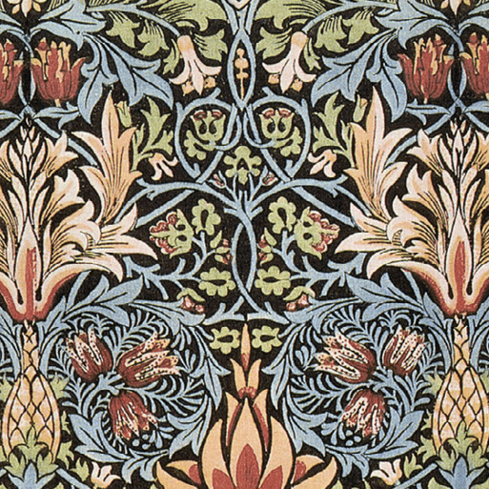  Functional and Fancy Fabrics – art focus  Key Concepts:  Compare and contrast  Cut and join  Decorating textiles  Evaluation  Everyday products  Generation of ideas  Investigation  Materials for purpose  Significant people  7 Programmes of study, 10 skills and 14 knowledge statements  Y4 Use research and develop design criteria to inform the design of innovative, functional, appealing products that are fit for purpose, aimed at particular individuals or groups.  Y4 Generate, develop, model and communicate their ideas through discussion, annotated sketches, cross-sectional and exploded diagrams, prototypes, pattern pieces and computer-aided design.  Y4 Select from and use a wider range of tools and equipment to perform practical tasks (for example, cutting, shaping, joining and finishing), accurately.  Y4 Select from and use a wider range of materials and components, including construction materials, textiles and ingredients, according to their functional properties and aesthetic qualities.  Y4 Investigate and analyse a range of existing products.  Y4 Evaluate their ideas and products against their own design criteria and consider the views of others to improve their work.  Y4 Understand how key events and individuals in design and technology have helped shape the world. | Evaluation  appearance  attractive  design criteria  evaluation  improvement  purpose  review  Success  Generation of ideas  annotate  design criteria  plan  Sketch  Everyday products  home furnishing  home product  Materials for purpose  comfortable  delicate  durable  fabric  flexibility  flexible  lightweight  man-made  material  natural  property  soft  strength  stretchy  strong  synthetic  textile  texture  tough  use  versatile  Waterproof  Significant people  Arts and Crafts movement  Morris & Co  William Morris  textile designer  Compare and contrast  appearance  colour  compare  component  different  embellishment  function  material  pattern  property  purpose  quality  similar  Size  Cutting and joining textiles  fraying  hem  pinking shears  running stitch  Sew  Decorating and embellishing textiles  block printing  diamond  pattern structure  trellis  wey | core knowledgeAnnotated sketches and exploded diagrams show specific parts of a design, highlight sections or show functions. They communicate ideas in a visual, detailed way.  specific knowledgeAnnotated sketches and exploded diagrams show specific parts of a design, highlight sections or show functions. They communicate ideas in a visual, detailed way. | Y4 skill 1 Use annotated sketches and exploded diagrams to test and communicate their ideas.
 |  | core knowledgeAnnotated sketches and exploded diagrams show specific parts of a design, highlight sections or show functions. They communicate ideas in a visual, detailed way.  specific knowledgeAnnotated sketches and exploded diagrams show specific parts of a design, highlight sections or show functions. They communicate ideas in a visual, detailed way. | Y4 skill 1 Use annotated sketches and exploded diagrams to test and communicate their ideas.
 |  | core knowledgeUseful tools for cutting include scissors, craft knives, junior hacksaws with pistol grip and bench hooks. Useful tools for joining include glue guns. Tools should only be used with adult supervision and safety rules must be followed.  specific knowledgeJoining tools to use with fabric include needles, pins and clips, cutting tools include a variety of scissors such as pinking shears, finishing tools include an iron and ironing board.  core knowledgeA hem runs along the edge of a piece of cloth or clothing. It is made by turning under a raw edge and sewing to give a neat and quality finish. | Y4 skill 1 Select, name and use tools with adult supervision.  Y4 skill 1 Hand sew a hem or seam using a running stitch.
 |  | core knowledgeDifferent materials and components have a range of properties, making them suitable for different tasks. It is important to select the correct material or component for the specific purpose, depending on the design criteria. Recipe ingredients have different tastes and appearances. They look and taste better and are cheaper when in season.  specific knowledgeFabrics can be natural or synthetic. Natural fabrics include cotton, silk and wool. Synthetic fabrics include Lycra, polyester and nylon.  core knowledgeBlock printing techniques and fabric paint are used to create decorative, repeated patterns on fabrics. | Y4 skill 1 Choose from a range of materials, showing an understanding of their different characteristics.  Y4 skill 1 Create detailed decorative patterns on fabric using printing techniques.
 |  | core knowledgeA comparison table can be used to compare products by listing specific criteria on which each product can be judged or scored.  core knowledgeDesign features are the aspects of a product's design that the designer would like to emphasise, such as the use of a particular material or feature that makes the product easier to use or more durable.  specific knowledgeDesign features include purpose and function, appearance, quality, material, size, colour, pattern, embellishment, durability and usability. | Y4 skill 1 Create and complete a comparison table to compare two or more products.  Y4 skill 1 Investigate and identify the design features of a familiar product.
 |  | core knowledgeEvaluation can be done by considering whether the product does what it was designed to do, whether it has an attractive appearance, what changes were made during the making process and why the changes were made. Evaluation also includes suggesting improvements and explaining why they should be made. | Y4 skill 1 Identify what has worked well and what aspects of their products could be improved, acting on their own suggestions and those of others when making improvements.
 |  | core knowledgeSignificant designers and inventors can shape the world.  specific knowledgeWilliam Morris was a British textile designer, artist and socialist activist associated with the British Arts and Crafts Movement. He was a significant contributor to the revival of traditional British textile arts and methods of production. | Y4 skill 1 Explain how and why a significant designer or inventor shaped the world.
Year 4  Electrical circuits and conductors – science focus  This project teaches children about electrical appliances and safety. They construct simple series circuits and name their parts and functions, including switches, wires and cells. They investigate electrical conductors and insulators and identify common features of conductors. It also teaches children about programmable devices. They combine their learning to design and make a nightlight.  Key concepts:  Compare and contrast  Electricity  Evaluation  Everyday products  Generation of ideas  Use of ICT  6 Programmes of study, 7 skills and 9 knowledge statements  Y4 Use research and develop design criteria to inform the design of innovative, functional, appealing products that are fit for purpose, aimed at particular individuals or groups.  Y4 Generate, develop, model and communicate their ideas through discussion, annotated sketches, cross-sectional and exploded diagrams, prototypes, pattern pieces and computer-aided design.  Y4 Investigate and analyse a range of existing products.  Y4 Evaluate their ideas and products against their own design criteria and consider the views of others to improve their work.  Y4 Understand and use electrical systems in their products (for example, series circuits incorporating switches, bulbs, buzzers and motors).  Y4 Apply their understanding of computing to program, monitor and control their products. | Evaluation  evaluation  feedback  finish  improvement  modification  Generation of ideas  annotated sketch  design criteria  exploded diagram  Everyday Products  design feature  nightlight  programmable  programmable device  sensor  switch  Materials for purpose  conductive  material  non-conductive  purpose  Compare and contrast  compare  electrical product  manual product  purpose  usability  Use of ICT  coding  micro:bit  program  programming  Electricity  LED  cell  circuit  coding  complete circuit  component  electricity  incomplete circuit  lamp  light-emitting diode  micro:bit  program  programming  push-to-break switch  push-to-make switch  reed switch  rocker switch  series circuit  toggle switch  wire | core knowledgeAnnotated sketches and exploded diagrams show specific parts of a design, highlight sections or show functions. They communicate ideas in a visual, detailed way. | Y4 skill 1 Use annotated sketches and exploded diagrams to test and communicate their ideas.
 |  | core knowledgeAnnotated sketches and exploded diagrams show specific parts of a design, highlight sections or show functions. They communicate ideas in a visual, detailed way. | Y4 skill 1 Use annotated sketches and exploded diagrams to test and communicate their ideas.
 |  | core knowledgeA comparison table can be used to compare products by listing specific criteria on which each product can be judged or scored.  core knowledgeDesign features are the aspects of a product's design that the designer would like to emphasise, such as the use of a particular material or feature that makes the product easier to use or more durable.  specific knowledgeA switch makes or breaks a circuit. When a switch is closed or 'on', the circuit is complete. When a switch is open or 'off', the circuit is incomplete.  specific knowledgeA programmable device is a machine that is able to be provided with coded instructions for the automatic performance of a task.  specific knowledgeA nightlight is a small electric light that gives out a dim glow. Design features of nightlights include a switch, light source and an attractive casing. | Y4 skill 1 Create and complete a comparison table to compare two or more products.  Y4 skill 3 Investigate and identify the design features of a familiar product.
 |  | core knowledgeEvaluation can be done by considering whether the product does what it was designed to do, whether it has an attractive appearance, what changes were made during the making process and why the changes were made. Evaluation also includes suggesting improvements and explaining why they should be made. | Y4 skill 1 Identify what has worked well and what aspects of their products could be improved, acting on their own suggestions and those of others when making improvements.
 |  | core knowledgeComponents can be added to circuits to achieve a particular goal. These include bulbs for lighthouses and torches, buzzers for burglar alarms and electronic games, motors for fairground rides and motorised vehicles and switches for lights and televisions. | Y4 skill 1 Incorporate circuits that use a variety of components into models or products.
 |  | core knowledgeRemote control is controlling a machine or activity from a distance. Computers can be used to remotely control a device, such as a light, speaker or buzzer. | Y4 skill 1 Write a program to control a physical device, such as a light, speaker or buzzer.
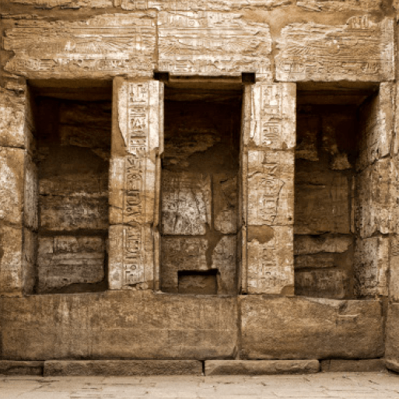  Year 4  Tomb Builders  This project teaches children about simple machines, including wheels, axles, inclined planes, pulleys and levers, exploring how they helped ancient builders to lift and move heavy loads.  Key concepts:  Evaluation  Materials for purpose  Mechanisms & movement  3 Programmes of study, 3 skills and 7 knowledge statements  Y4 Select from and use a wider range of materials and components, including construction materials, textiles and ingredients, according to their functional properties and aesthetic qualities.  Y4 Evaluate their ideas and products against their own design criteria and consider the views of others to improve their work.  Y4 Understand and use mechanical systems in their products (for example, gears, pulleys, cams, levers and linkages). | Evaluation  change  evaluate  evaluation  improve  Success  Generation of ideas  annotated sketch  labelled diagram  prototype  Everday products  compound machine  device  simple machine  Materials for purpose  characteristic  material  property  rigid  smooth  Strength  Mechanisms and movement  axle  compound machine  effort  first class  force  fulcrum  inclined plane  lever  load  pulley  screw  second class  simple machine  third class  wedge  wheel | core knowledgeDifferent materials and components have a range of properties, making them suitable for different tasks. It is important to select the correct material or component for the specific purpose, depending on the design criteria. Recipe ingredients have different tastes and appearances. They look and taste better and are cheaper when in season.  specific knowledgeCharacteristics of materials, such as rigidity, strength and smoothness will affect the success of a working model. | Y4 skill 1 Choose from a range of materials, showing an understanding of their different characteristics.
 |  | core knowledgeEvaluation can be done by considering whether the product does what it was designed to do, whether it has an attractive appearance, what changes were made during the making process and why the changes were made. Evaluation also includes suggesting improvements and explaining why they should be made. | Y4 skill 1 Identify what has worked well and what aspects of their products could be improved, acting on their own suggestions and those of others when making improvements.
 |  | core knowledgeMechanisms can be used to add functionality to a model. For example, sliders or levers can be used in moving pictures, storybooks or simple puppets; linkages in moving vehicles or puppets; gears in motorised vehicles or spinning toys; pulleys in cable cars or transport systems and cams in 3-D moving toys or pictures.  specific knowledgeSimple machines make physical jobs easier by changing the strength or direction of a force. There are six simple machines: pulley; lever; wheel and axle; wedge; inclined plane; and screw. Simple machines can be combined to make complex, compound machines.  specific knowledgeSimple machines make physical jobs easier by changing the strength or direction of a force.  specific knowledgeSimple machines including pulleys, levers, wheels and axles and inclined planes can be combined to make a machine that can move heavy objects | Y4 skill 3 Explore and use a range of mechanisms (levers, axles, cams, gears and pulleys) in models or products.

